Basic Styling Template

Christine Hodges

Rasmussen College

Author Note

This paper is being submitted on May 19th, 2018 for Darice Corey CIS4655 Advanced Mobile Web Application Development course.

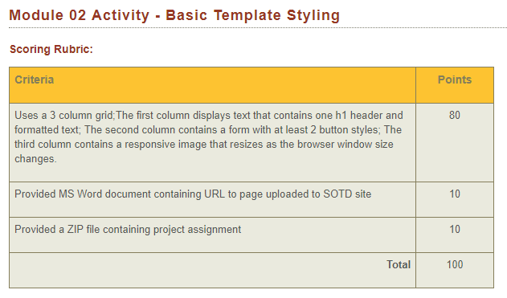

URL to uploaded SOTD site:

<http://sotd.us/christinehodges/AdvWebDev/Module_02/activity/mod2_activity.html>